# **TOTAL MARKS:70 DURATION: 3 HOURS**

**General Instructions:**

1. *Students are not required to create tables/schema for any question.*
2. *Students may create tables if it helps them solve the problem, but marks are allocated only for the queries.*
3. *Students are required to follow the exact same nomenclature provided in the ER/Table Design Schema including Table Name, Column Name and any Constraints.*
4. *Please follow the same order as in question paper for answering questions.*

**SECTION A: 20 MARKS (4 X 5 marks)**

**Refer the below Delivery database ER diagram to answer the questions.**

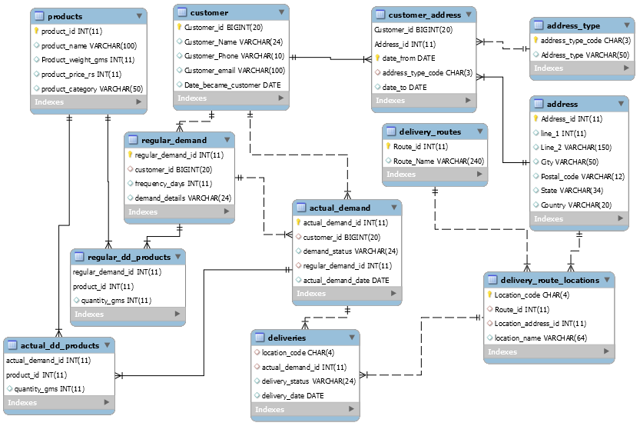

1. Find out the customers who belong to outside India **(5 marks) (use table: -address, customer_address).**
2. For the actual product demands, display the quantity and product greater than 1500, less than 1500 and equal to 1500 based on the quantity gms for the products other than rice. **(5 marks)**
   1. **(use table: - products,actual_dd_products)**
3. Find out the total number of customers from each City **(5 marks) (use table: -** **address, customer_address)**
4. As per the process, all the goods ordered must be delivered in 7 days. Find out those ‘actual_demand_id’s, there actual date and delivery date which were not delivered on time. **(5 marks) (use table: - actual_demand, deliveries)**

**SECTION B: 20 MARKS (20 marks)**

**Refer the Delivery database ER diagram to answer the question.**

1. Get the name and contact number/ mail of the customers who have cancelled the delivery**. (5 marks) (use table:-actual_demand,deliveries)**
2. Find out whether bsearch should have the same bids as gsearch (non-brand). Could you help to pull non-brand conversion rates from sessions , orders for gsearch and bsearch, and slice the data by device type?

Please analyse the data from August 22 to September 18 2012; To run a special pre-holiday campaign for gsearch starting on September 19th

(Use tables: -orders, sessions_website) Expected output is given below:**(15 Marks)**

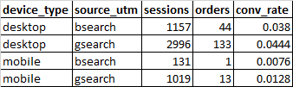

**SECTION C: 30 MARKS (3 X 10 marks)**

**The Questions below are scenario based questions based on a real time industry Problem. While answering the questions that requires queries to be written, necessary columns can be assumed to be present in the table. Also any hypothetical criteria can be assumed to for filtering the data and can be used in where statements and the query can be formed.**

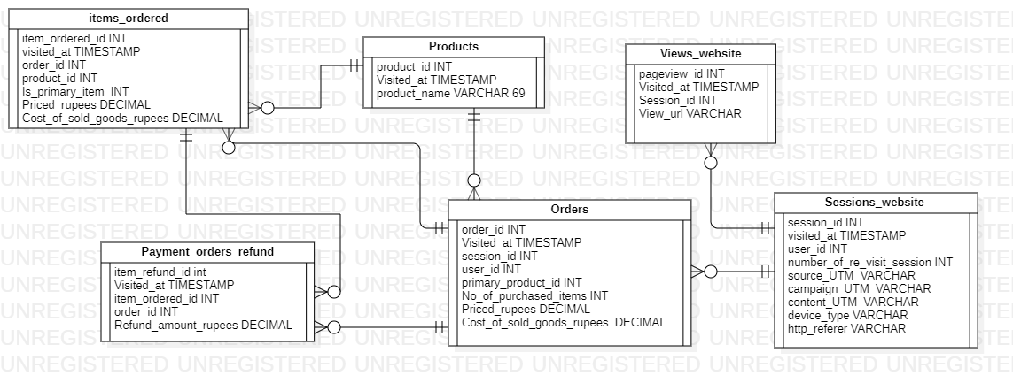

**Table Descriptions:**

Traffic source analysis is about understanding where your customers are coming from and which channels are driving the highest quality traffic.

**Sessions_website** – provides details about the website visit, time of visit, user who visited and other information

**Orders** – provides information about the orders placed in the websites

**Payment_Orders_Refund –** Provides details about the items which were requested for refund.

**Products**  - The details of the products present in website

**Items Ordered** – items and the details of the items that were ordered

**Views_Website** – details of the pages viewed in every session.

1. We have introduced and deployed our second product back on 06-01-2013, Can you fetch together some trend analysis? We would be happy to see monthly order volume, overall conversion rates, revenue per session, and a breakdown of sales by product, all for the time period of 5th month of 2012 to January 2013.

**Formulas you can use :-**

**Order_id/Session_id=Conversion rate**

**priced_rupees/Session_id=revenue per session**

**(Use tables: -orders, sessions_website)**

**(10 Marks)**

**Expected Output shown below:-**

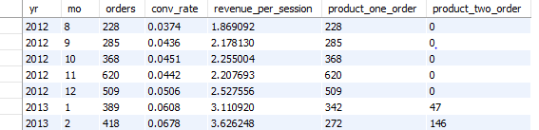

**Scenario:**

How to know if an app is successful? The below metrics are used to understand an Apps success.

**Metrics:**

1. **Number of users (User engagement)** - The first measure of success for an app is how many people actually download and intend to use the app. This is your initial look at user engagement since your first goal should be to achieve a broad user base.
2. **Source of the installation** - future channels for advertising and future marketing efforts
3. **Activation Rate -** This is the percentage of people who downloaded the app who actually launch it for use.
4. **Daily Active Users (DAU)** - This number will tell you whether people are using the app and how many people find your app indispensable. The Metric tells you each individual using the app, not the number of sessions. So each person is counted once, whether they use the app once a day or many times a day.
5. **Monthly active users (MAU)** - the unique number of people who use the app over the course of a specific month, or the prior 30 days. It will even break it down into four segments: 1-day, 7-day, 14-day, and 30-day active users. These are unique users who opened sessions on the app over the timeframe selected.

**Table: GooglePlayStore**

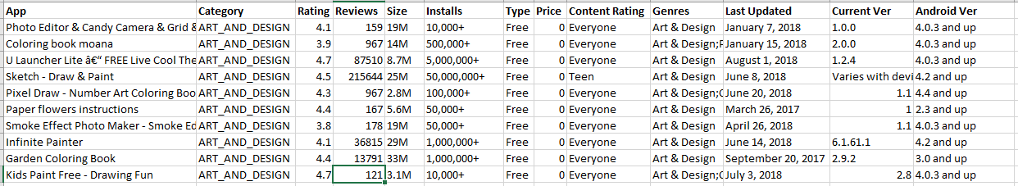

**Table: User_Session_Data**

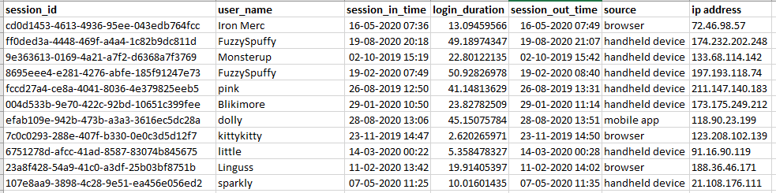

**Considering the Data Snips from 2 tables.**

**GooglePlayStore –** Has data for all apps and the details about them.

**User_Session_Data** – Has details about one single App and its login sessions.

1. An App Developer would like to have a report of the apps that were updated in the previous month.(Here as the data is captured last till the month of August,2018.We would like to take the records that fall into the date range of the month July. Perform appropriate Date conversions). **(10 Marks)**
2. An App owner has requested analysis to understand how many people find his app indispensable at least on a monthly basis in the recent past month.( Consider the latest month from data). **(10 Marks)**